Campaign Management APIs

- Generate Access Token
API URL: api/auth/generateToken
Method: POST
Headers: -NONE-
Payload:
- “username” is mandatory
{
"username": "Sree"
}
Response:
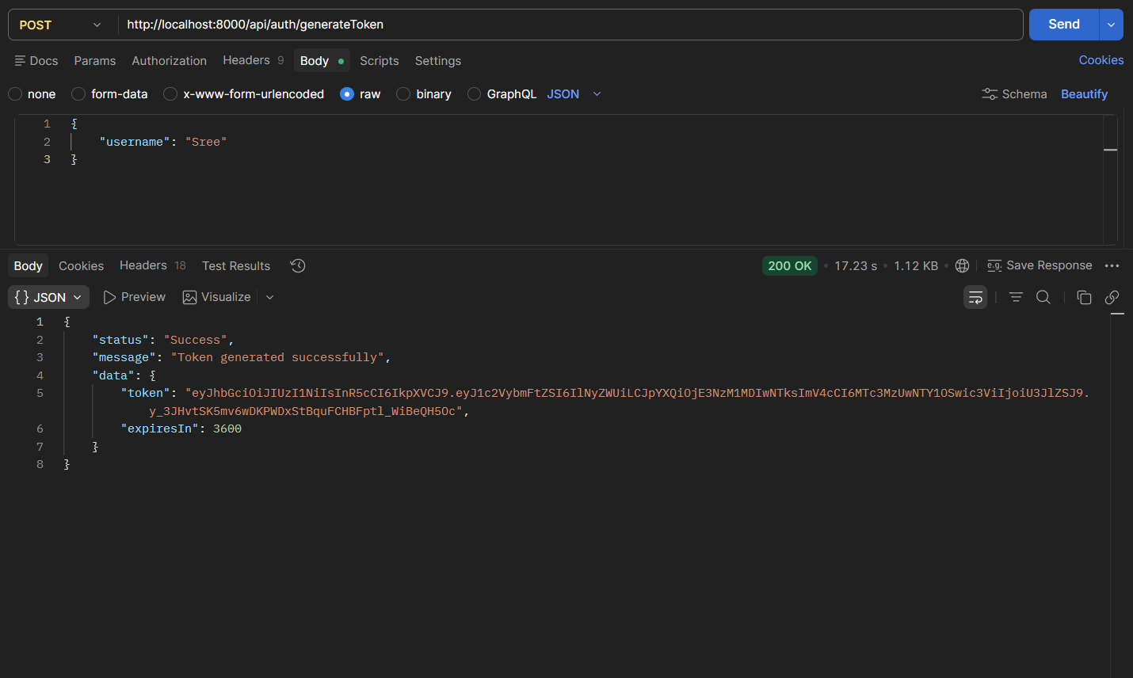

--------------------------------------------------------------------------------------------------------------------------
- Get Campaigns
API URL: api/campaign
Method: GET
Headers:
{
"Authorization": "Bearer XXXXX"
}
Payload: -NONE-
Response:
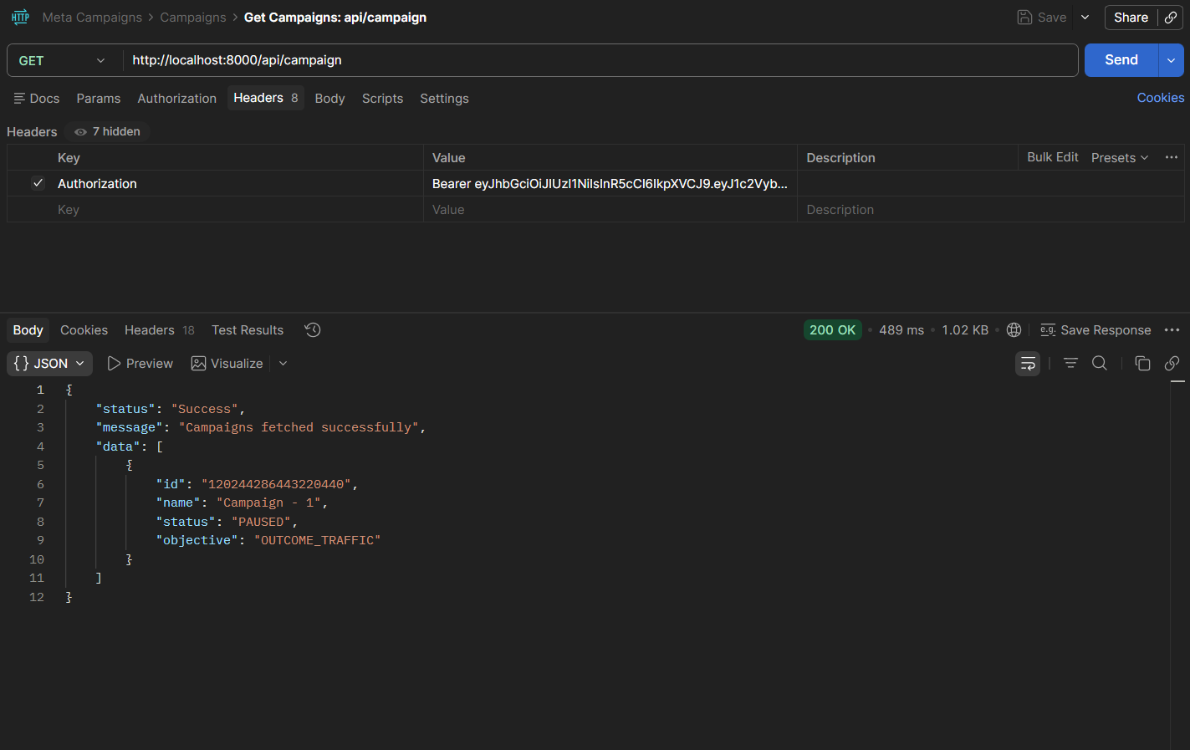

--------------------------------------------------------------------------------------------------------------------------
- Get Individual Campaign by Campaign Id
API URL: api/campaign/:campaignId
Method: GET
Headers:
{
"Authorization": "Bearer XXXXX"
}
Payload: -NONE-
Response:
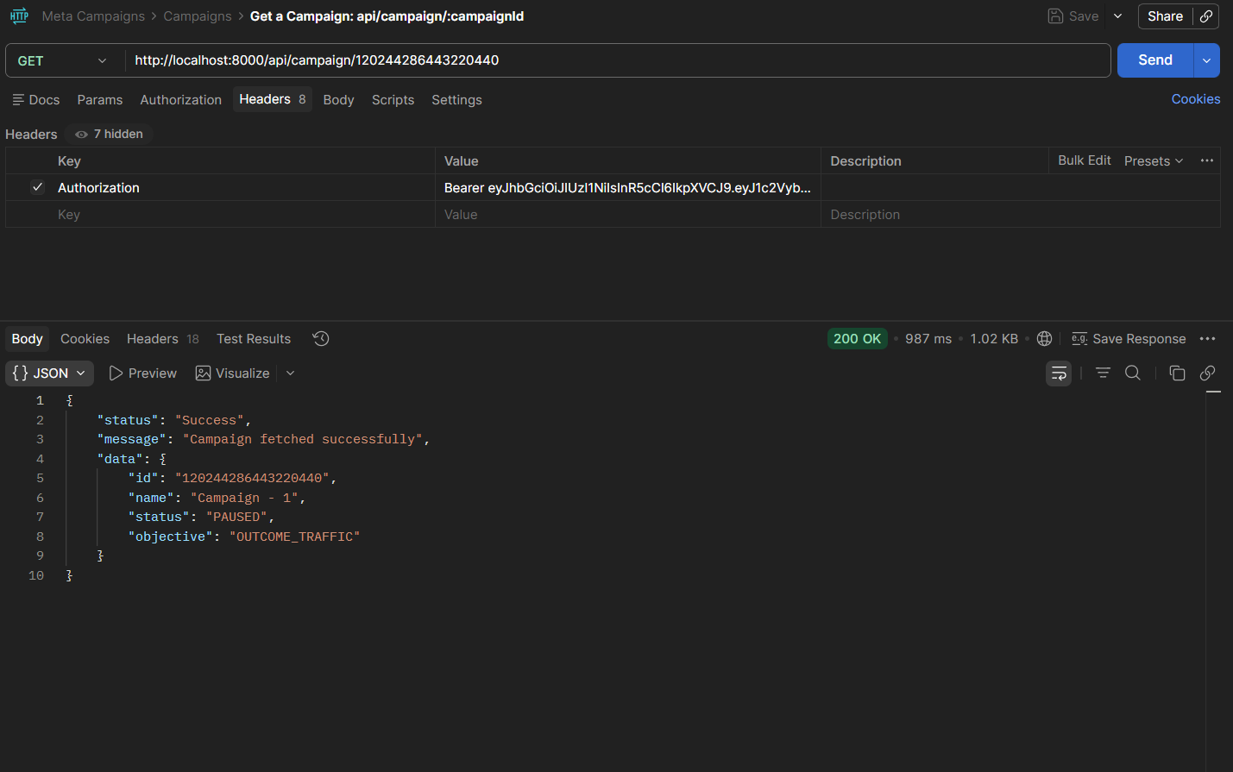

--------------------------------------------------------------------------------------------------------------------------
- Create Campaign
API URL: api/campaign/create
Method: POST
Headers:
{
"Authorization": "Bearer XXXXX"
}
Payload:
- “campaignName” is mandatory
{
"campaignName": "Campaign - 1"
}
Response:
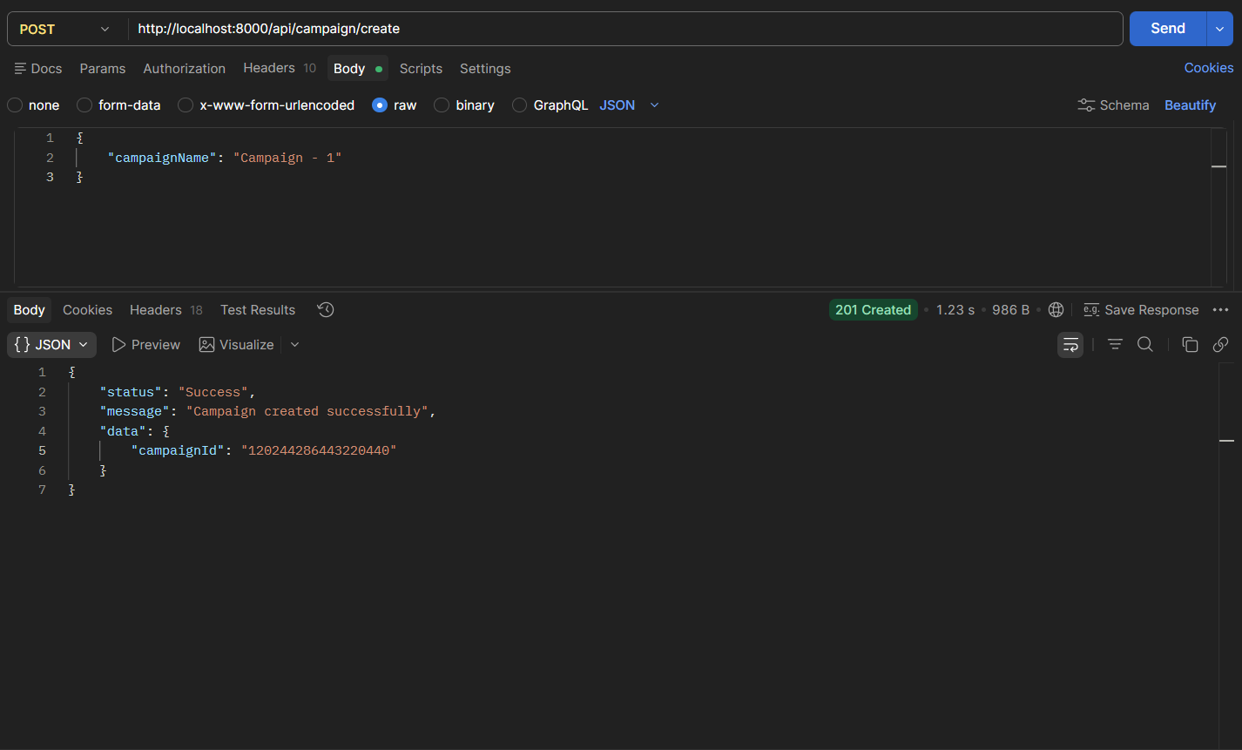

--------------------------------------------------------------------------------------------------------------------------
- Edit Campaign Details
API URL: api/campaign/edit
Method: PATCH
Headers:
{
"Authorization": "Bearer XXXXX"
}
Payload:
- “campaignId” is mandatory and valid
- “campaignName” is mandatory
{
"campaignId": "120244286443220440",
"campaignName": "Campaign - 1"
}
Response:
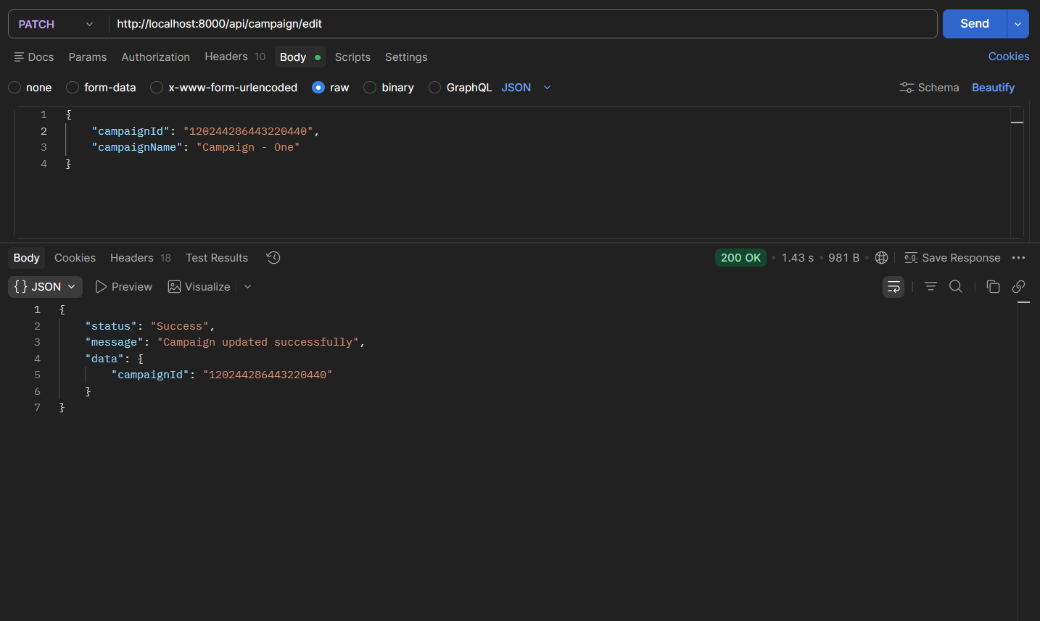

--------------------------------------------------------------------------------------------------------------------------
- Delete Campaign
API URL: api/campaign/:campaignId
Method: DELETE
Headers:
{
"Authorization": "Bearer XXXXX"
}
Payload: -NONE-
Response:
